Shenzhen Hawk Medical Instrument Co., Ltd.

USER MANUAL

Fluid Warmer
FW2-VET

（Version: V1.0.0, Edit Date:2021.01.07）

057-00134-01

Contents
1. Product overview 1
1.1 Main Composition and Structure 1
1.2 Applicable Range 1
1.3 Product Performance 1
1.4 Medical Electronic Device Safety Classification 1
1.5 Operational Environment 1
1.6 Effects to Environment and Energy Resource 1
1.7 Contraindication 1
1.8 Attentions 1
2. Exterior Diagram 2
2.1 Complete Machine Diagram 2
2.2 Accessory 2
3. Introduction of Operation Interface 3
3.1 Switch on, Operating and Standby Interfaces 3
3.2 Introduction of Operation Interface 3
4. Installation & Operation Instructions 3
4.1 Installation 3
4.2 Instructions for use 4
4.3 Power on / off 6
4.4 Operation Steps 6
4.5 Alarms and solution 7
4.6 Operation precautions 8
4.7 Special instructions for the personal use 8
5. Product accessories, consumables 8
5.1 Product accessories, consumables 8
5.2 Instructions of product accessories, consumables 8
5.3 Product accessories replacement cycle and replacement methods 8
5.4 Product accessories, consumables precautions 8
6. Product maintenance and maintenance methods 9
6.1 Routine maintenance 9
6.2 Troubleshooting and solution 9
7. Transport and Storage 10
8. Product life 10
8.1 Production date 10
8.2 Product life 10
9. Product labels explanation 10
9.1 Product labels ( on the back shell of Fluid warmer ) 10
9.2 Symbols and Significance 10
10. After sales service 11
11. Electromagnetic Compatibility (EMC) Information 11

1. Product overview

1.1 Main Composition and Structure
Fluid warmer is mainly composed of microcomputer, heating system, temperature detection system, temperature control system, alarm system, man-machine interface etc, and equipped with one external drop sensor.

1.2 Applicable Range
Fluid warmer is an equipment heating liquids inside blood transfusion tube/ infusion tube based on thermal transfer principle, therefore, it is mainly used to heat liquid infused to human by transfusion tube/ infusion tube.
Users of this device must be well trained professional persons.

1.3 Product Performance
Power supply: AC 100V—240V 50Hz/60Hz
Input power: ≤150W
Temperature control accuracy: ≤ ±1℃/1.8℉
Temperature control range: 30℃～50℃/（86℉～122℉） (The controlled temperature is 10℃/ 50℉ higher than surrounding temperature)
Safety measures: Visual and audible alarm for over-temperature and low-temperature.
Automatically power cut if the heater's temperature reaches 56℃ ± 3℃.
Monitoring drip rate, bottle empty and giving alarm. (Optional)
Complete machine weight: <1kg
Dimension: 172*92*55 mm

1.4 Medical Electronic Device Safety Classification
Class I

1.5 Operational Environment
- Temperature: 5℃ - 30℃
- Relative humidity: 10% - 93% (No frost)
- Atmosphere pressure: 86.0 kPa～106.0 kPa

1.6 Effects to Environment and Energy Resource
The fluid warmer may have a certain amount of electromagnetic radiation, which may interfere other devices. If this situation occurs, please take appropriate measures to reduce the interference, such as adjust the device's location, or connect power supply from other sources. For further information, please refer to EMC Information (Chapter Ⅺ of this user manual).

1.7 Contraindication
Not applicable to heat-sensitive drugs.

1.8 Attentions
(1) This device is used to heat drugs(or blood) inside infusion tube/blood transfusion tube. Don't use it for other purposes.
(2) Please follow doctor's instruction when using this device, ensure the drug can be heated, and check appropriate heating temperatures.
(3) Prevent impact or knocking on the device, please pick up and lay down gently.
(4) Please don’t heat broken blood transfusion tube or infusion tube.
(5) Read this user manual before installation and operation.
(6) Don't wash this device.

2. Exterior Diagram

2.1 Complete Machine Diagram
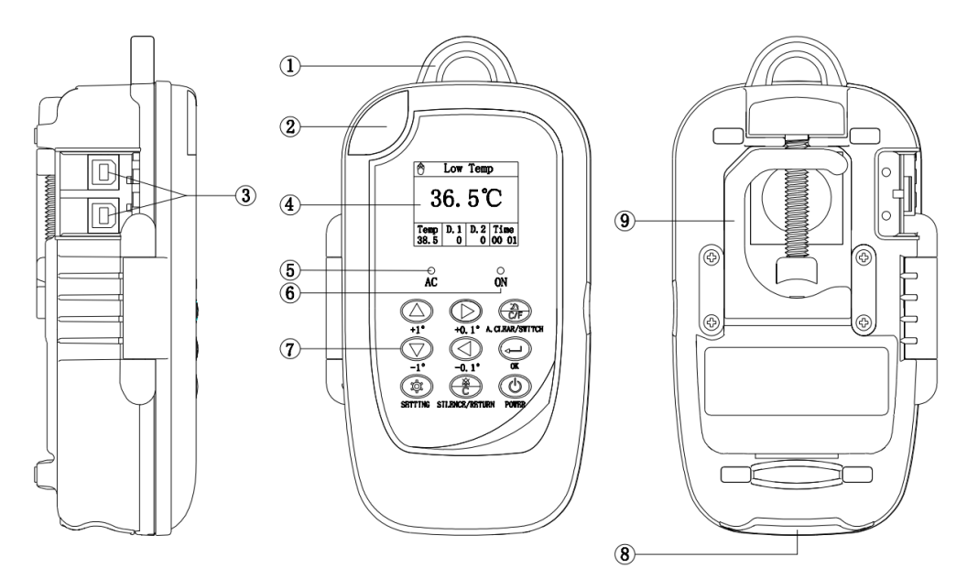
①hand ring ②light cover ③drop sensor port
④Display interface ⑤ AC indicator light ⑥switch on indicator light
⑦keypad ⑧Power cable interface ⑨Fixing clamp(Hidden status)

2.2 Accessory
Suspension belt
Power cable
Drop sensor (Optional, shown as right-side picture)
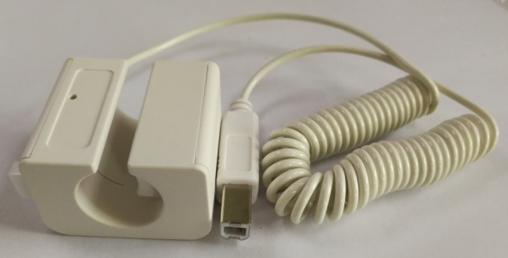
Note: While using the drop sensor, the machine can give drip abnormal and empty bottle alarm.

3. Introduction of Operation Interface

3.1 Switch on, Operating and Standby Interfaces
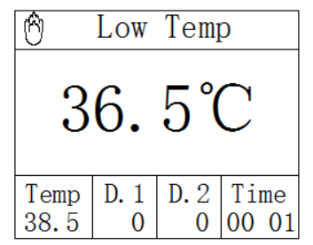

3.2 Introduction of Operation Interface
Please refer to section 4.2 of this user manual.

4. Installation & Operation Instructions

4.1 Installation
Two methods to install this device:
1. Use suspension belt to hang the device
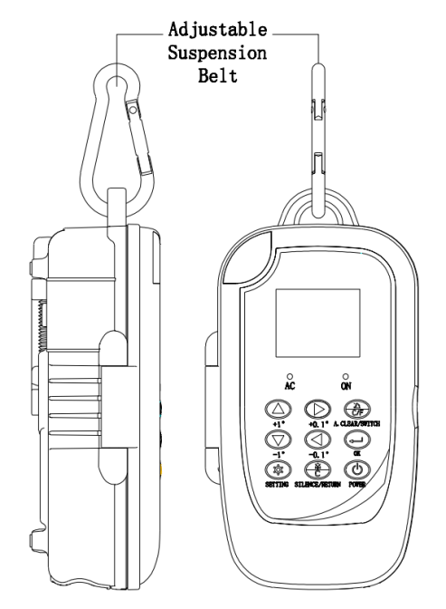

- Pole Clamp install illustration:(Open the hidden pole clamp and rotate 90 °, same as below second photo)
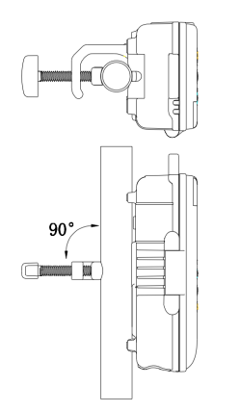
Note: This device has two Tube Channel Installation Slots for warming the fluid or blood, can be installed two Tube Channels or one Tube Channel. Illustration as below:
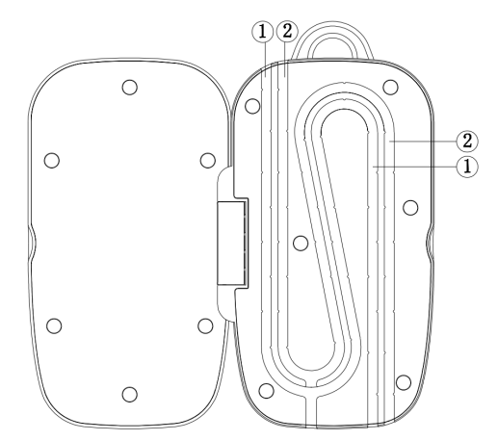
①：1st Tube Channel Installation Slot
②：2nd Tube Channel Installation Slot

4.2 Instructions for use
The product is mainly used for heating the fluid or blood in transfusion tube.
In addition, it can detect the infusion drop rate and alarm when bottle is empty.

1. Instructions of keypad：
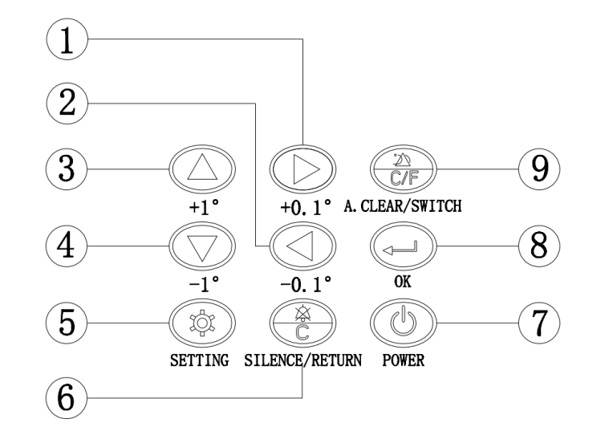

Serial number | Description | Function
① | 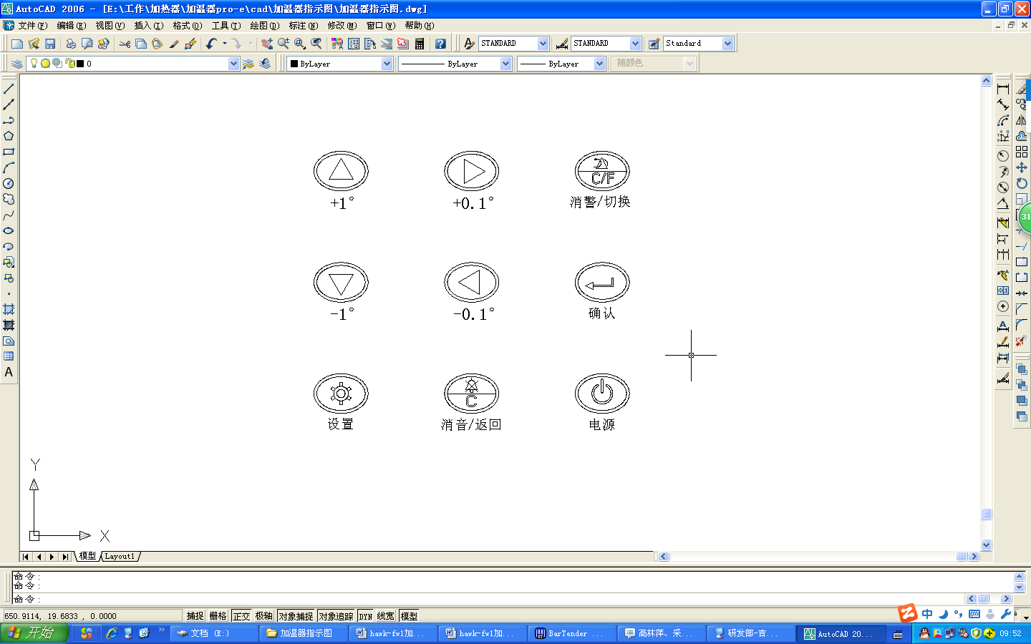 | In main interface or standby interface means +0.1° temperature value. In setting menu interface, it indicates "To Right" navigation key
② |  | In main interface or standby interface means -0.1° temperature value. In setting menu interface, it indicates "To Left" navigation key
③ |  | In main interface or standby interface means +1° temperature value. In setting menu interface, it indicates "To UP" navigation key
④ |  | In main interface or standby interface means -1° temperature value. In setting menu interface, it indicates "To Down" navigation key
⑤ |  | Enter the setting menu
⑥ |  | Return to the upper level menu; clear the alarm sound if there’s alarm
⑦ |  | Power key – Keep pressing Power for seconds to switch on/ switch off the device
⑧ | 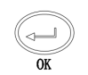 | In setting menu interface Enter is confirm key, No effect in the main menu
⑨ |  | In the main menu, Switch to the unit of temperature. It can clear the alarm sound if there’s alarm

2. Main Interface:
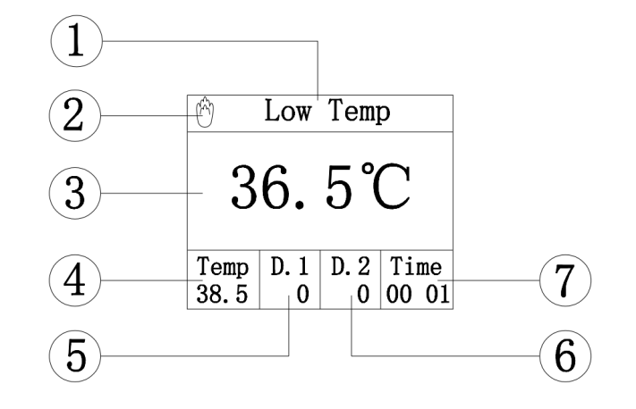

Serial number | Description | Function
① | Alarm Display Area | When alarm occurs, display the relevant alarm symbol
② | Heating Symbol | When the symbol is displayed, it indicates that the heating plate is warming up
③ | Real-time Temperature | Display Heating Plate Real Time Temperature
④ | Set the temperature | Display the setting temperature
⑤ | Drop 1 | Drop rate of 1st Tube Channel
⑥ | Drop 2 | Drop rate of 2nd Tube Channel
⑦ | Operating Time | Total operating time of the device

3.Setting interface:
After press "SETTING" Key, enter the following interface sequentially:
Interface | Description | Function
1st Interface | Temperature setting | Set the target temperature and press "OK" key to save the settings
1st Interface | Drop sensor1 Setting  (optional) | When using with drop sensor, set empty bottle alarm and drop abnormal alarm.  - Set Drop rate of the 1st channel. Default: 100 drops/min  - set Empty alarm as ON.  - Set drop abnormal alarm as ON.  - Set the alarm activation range  Default: 10%. (For example, when drop rate is 200 drops/min; the range is 10%, which means the device will give drop abnormal alarm when real drop rate is out of 180-220 drops/min.  After setting, press Return key to last interface.  Attention: When the fluid warmer doesn’t use with drop sensor, please ignore this function. Please keep all the alarms in this interface as OFF.
1st Interface | Drop sensor2 Setting  (optional) | When using with drop sensor, set empty bottle alarm and drop abnormal alarm.  - Set Drop rate of the second channel. Default: 100 drops/min  - set Empty alarm as ON.;  - Set drop abnormal alarm as ON.  - Set the alarm activation range  Default: 10%. (For example, when drop rate is 200 drops/min; the range is 10%, which means the device will give drop abnormal alarm when real drop rate is out of 180-220 drops/min.  After setting, press Return key to last interface.  Attention: When the fluid warmer doesn’t use with drop sensor, please ignore this function. Please keep all the alarm settings in this interface as OFF.
1st Interface | Backlight | Set the LCD screen backlight brightness Light or Dark, and press the "OK" key to save the settings
2nd Interface | Volume | Set the speaker volume, the speaker volume is 8 levels, and press the "OK" key to save the settings, High volume>65dB, Low volume≥45dB
2nd Interface | Key sound | Set the key sound to ON or OFF, and press the "OK" to save the settings
2nd Interface | Restore to factory settings | Restore all the specifications to factory settings
2nd Interface | Language Settings | Select English, French, Italian, Spanish, Russian and so on. Press “OK” key to save settings
3rd Interface | Temp Err Alarm  (Temperature error alarm) | When setting this function as ON, and the range setting as 1℃, when real temperature is higher or lower than target temperature for 1 ℃, the device will give Temp error alarm. The range setting could be 1-4 ℃.  When this function is setting as Off, the device will not give alarm when real temperature is higher or lower than target temperature for 1-4℃, but the device will still give high temperature alarm when real temperature is higher than 51℃, and will give low temperature alarm when real temperature is lower than 29℃.  The default setting is Off.
3rd Interface | Device Information | Review the information of device, version, etc.

4.3 Power on / off
1. Keep pressing “Power” key until the LCD display is ON
2. Keep Pressing “Power” key 2 seconds, the display will be off.

4.4 Operation Steps
1. Clean the surface of the Fluid Warmer.
2. Fix the device per the install illustration, connect to power supply;
3. Install the fluid/blood transfusion tube to the corresponding heating plate slot, close the front cover, insert the drop sensor into the corresponding socket (if required), Press "Power" key, the indicator of "ON" will be lighted, and the fluid warmer starts system self-test, if any abnormal the warmer will give audible and visual alarm.
4. According to the actual need to set the parameters, and press the "OK" key to save the settings, after back to the main interface, the Fluid Warmer will operate normally;
5. Switch off the device, and pull out the power plug from the AC socket after warming.
6. Clean the surface of the Fluid Warmer and store it correctly.

4.5 Alarms and solution
Description | Alarm | Reasons and Solutions
Door Open | The front cover is open or not cover well | Detect the front cover is opened or not cover well, show alarms in visual and audible, press “SILENCE/RETURN” key to clear the audible alarm
Temp Err | Temperature Error. The temperature is 1-4℃ higher or lower than the target temperature | Heating function is abnormal. Show visual and audible alarm, when the temperature goes back to the control range, the alarm will disappear automatically. Press “SILENCE/RETURN” key to clear the audible alarm.  Try again, if the alarm still exists, please return to factory for repair.
HighTemp | Temperature is higher than 51℃ | When device detects temperature higher than 51℃, it will give high temperature alarm. Show visual and audible alarm, when the temperature goes back to the control range, the alarm will disappear automatically. Press “SILENCE/RETURN” key to clear the audible alarm.
Low Temp | Temperature is lower than 29℃ after heating stably | When device detects temperature lower than 29℃, it will give low temperature alarm. Show visual and audible alarm, when the temperature goes back to the control range, the alarm will disappear automatically. Press “SILENCE/RETURN” key to clear the audible alarm.
Empty 1 | Drop 1 Empty | Detect the infusion bottle of 1st tube channel is empty. Show visual and audible alarm, press ”A.CLEAR/SWITCH” key to clear the visual alarm, press ”SILENCE/RETURN” key to clear the audible alarm.
Empty 2 | Drop 2 Empty | Detect the infusion bottle of 2st tube channel is empty. Show visual and audible alarm, press ”A.CLEAR/SWITCH” key to clear the visual alarm, press ”SILENCE/RETURN” key to clear the audible alarm.
Drop1Err | Drop 1 Error/ Abnormal | Detect drop rate of 1st tube channel is abnormal. Show visual and audible alarm, when Drop rate goes back to the correct rate, then the alarm will disappear automatically. Press ”SILENCE/RETURN” key to clear the audible alarm.
Drop2Err | Drop 2 Error/ Abnormal | Detect drop rate of 2nd tube channel is abnormal. Show visual and audible alarm, when Drop rate goes back to the correct rate, then the alarm will disappear automatically. Press ”SILENCE/RETURN” key to clear the audible alarm.
Error E3 | System data error | Detect system data error/ abnormal. Show visual and audible alarm, the alarm will disappear after restoring factory settings

4.6 Operation precautions
1. Before operating the device, please check with the pharmacist, make sure the medicine can be heated or not and what’s the appropriate temperature.
2. Before operating the device, please check the device is damaged or not, any liquid or wet there; if the panel is damaged, please replace it in time, avoid the medicine leaking inside to damage the device.
3. Please refer to the illustration of user manual to install the device correctly and stably, avoid the device falling from infusion set. Please don’t block the speaker.
4. Please operate the device per above operation steps. If there is alarm, must solve it, if necessary, contact the local distributor for repair and test it qualified then can continue to use it.
5. If using the drop sensor, make sure the drop sensor socket is corresponding to the right infusion tube slot.
6. The device must be operated by well-trained professionals only.

4.7 Special instructions for the personal use
Do not recommend for personal use. If consumers have to use it individually, must check with pharmacist the medicine can be heated or not, and confirm the appropriate heating temperature too.

5. Product accessories, consumables

5.1 Product accessories, consumables
1.Suspension belt 2. Power cord 3. Drop sensor (Optional)

5.2 Instructions of product accessories, consumables
Please refer to 2.2 accessories illustration.

5.3 Product accessories replacement cycle and replacement methods
Replace if damaged. Please refer to 4.1 illustration for replacement methods

5.4 Product accessories, consumables precautions
Not yet found.

6. Product maintenance and maintenance methods

6.1 Routine maintenance
1. Should inspect the function of temperature controlling regularly (once every 2 months) as below steps:
Switch on the device in room temperature (20±2)℃, set the device temperature to 36°C, when the device heating is stable (The heating symbol 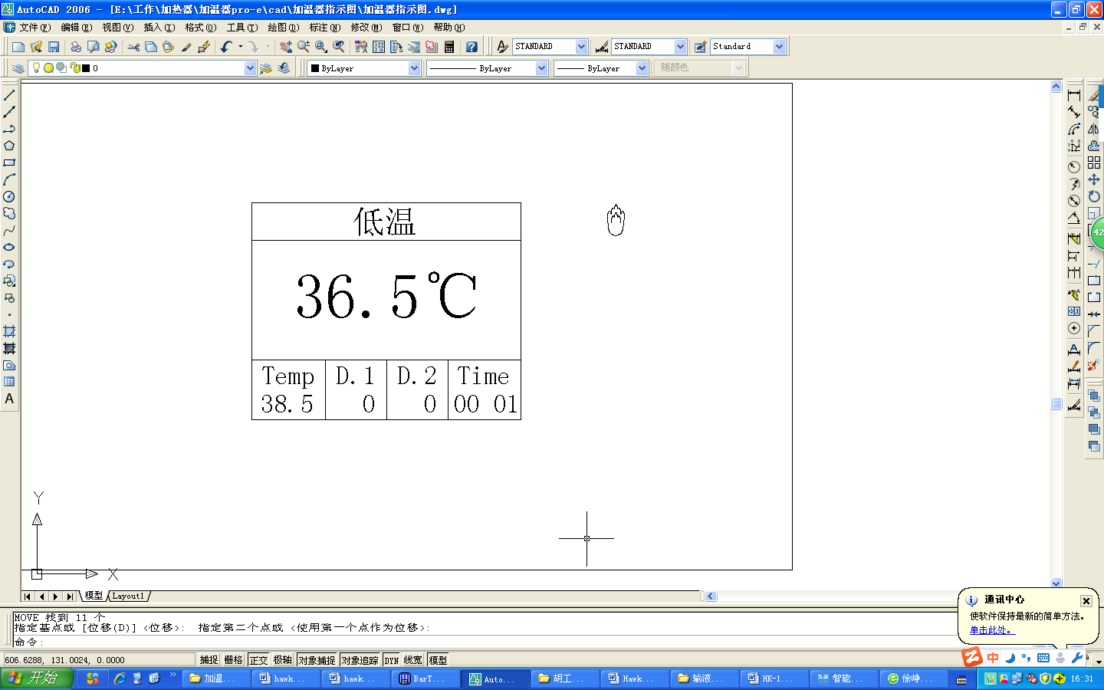disappear), check the display temperature on interface, and use the temperature measure equipment to test the temperature of the heating grooved plate, both should in the range of 36±1℃.(Note: The accuracy of temperature measure equipment is ±1℃).
2. Keep surface of the device clean. Clean the surface with wet cloth adding cleaner, then wipe it with wet cloth, finally dry it with cloth and store it on clean shelf. Do not use solvents like xylene, acetone or similar solvents which leads to corrode the Fluid Warmer.
3. The heating surface should be cleaned thoroughly before and after use to avoid cross infection.
4. Keep the surface of the warmer away from sharp objects, otherwise the damages of the Fluid Warmer may lead to the tube channel broken, thus may cause patients’ infection.
5. Keep the surface of the tube channel dry. Forbid any liquid immersing into the Fluid Warmer.
6. Inspect the pole clamp of Fluid Warmer before operation, prevent it falls during using and hurt people & damage device.
7. The lifetime of device is 5 years, it should be scrapped after using 5 years, please contact with manufacturer for more details.

6.2 Troubleshooting and solution
When the following situations appear, means the device is broken down, please solve it per the following methods.

Failure | Cause analysis | Solution
AC lights is not on | 1. No AC power supply  2. Control circuit failure | 1. Check the AC power supply  2. Contact the manufacturer/distributor
Not heated | - Control circuit failure  - Heating device failure  - The heater failure | - Contact the manufacturer/distributor  - Contact the manufacturer/distributor  - Contact the manufacturer/distributor
Message shows partially | LCD display abnormal | Contact with the manufacturer
Alarm Note Error E1 | It means the internal temperature detector has failed. | The temperature detector is loose or damaged. Press the "SILENCE/RETURN" key to clear the sound prompt. Contact the manufacturer/distributor to deal with.
Alarm Note Error E3 | It means incorrect parameter and need restore factory settings. | Parameter storage error, need to restore the factory settings. Press the "SILENCE/RETURN" key to clear the sound. Enter the settings interface, select "restore factory settings" to return to normal.
When appearing 4.5 alarm, the alarm cannot be eliminated even when the problem was solved. |  | 1. Contact the manufacturer/distributor

7. Transport and Storage
Storage conditions: Temperature: -20℃～+60℃;
Relative humidity: 10%～93%(no frosting);
Atmosphere pressure: 50.0 kPa～106.0 kPa;
Transport:
Place the product as per No. of layers indicated on packing carton.
Temperature: -20℃～+60℃;
Relative humidity: 10%～93% (no frosting);
Atmosphere pressure: 50.0 kPa～106.0 kPa;

8. Product life

8.1 Production date
See product label

8.2 Product life
The product life is 5 years.

9. Product labels explanation

9.1 Product labels ( on the back shell of Fluid warmer )
This label according to the relevant standards, displaying manufacturer, production date, batch No., equipment classification and other information.

9.2 Symbols and Significance
Symbols | Descriptions | Symbols | Descriptions
 | Production batch No. |  | Protective Earthing
 | Product serial No. | IPX3 | Waterproof level: dripping water by slope angel 60°
 | Caution, consult accompanying documents |  | AC power
 | Type CF |  | DC power
 | Date of production |  | Caution, consult instruction for use
 | Manufacturer | 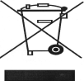 | Dispose in environmental-friendly way

10. After sales service
The free warranty for the fluid warmer is one year.
Note: The following situation is not within the range of free maintenance and repair.
(1) Malfunctions resulting from improper operation, or modification / repair of the fluid warmer without supplier’s knowledge and permission.
(2) Bruise or damage caused by improper handling during transport.
(3) Malfunction or damage caused by fire, salt, poisonous gas, earthquake, hurricane, flood, abnormal electric voltage or any other natural disaster.
For all the malfunctions and damage due to above reasons, the manufacturer can offer repair but charge for the cost.

11. Electromagnetic Compatibility (EMC) Information
Attention:
- The fluid warmer meet YY0505 standard electromagnetic compatibility requirements;
- The user should install and use the electromagnetic compatibility information provided by the random document;
- Portable and mobile RF communication devices may affect the performance of the fluid warmer, use to avoid strong electromagnetic interference, such as near mobile phones, microwave ovens, etc.
- The guide and the manufacturer's statement are described in the annex.
Warning:
- The fluid warmer should not be close to or stacked with other equipment, if you have to close or stacked use, you should observe the verification in the use of its configuration can be normal operation;
- Class A equipment is intended for use in industrial environments, and it may be difficult to ensure that electromagnetic compatibility is potentially difficult in other environments due to the fluid warmer conduct harassment and radiation harassment;
- Besides internal components provided by manufacturer of the fluid warmer, using the other brand accessories and cables may result in the fluid warmer increasing emitting or decreasing immunity.
Enclosure：
Guidance and manufacturer's statement - Electromagnetic emission
FW2-VET fluid warmer is expected to be used in the following specified electromagnetic environment, the purchaser or the user should ensure that it is used in this electromagnetic environment:
Emission Test | Compliance | Electromagnetic Environment–Guidance
Radio-frequency emission  GB 4824 | Group 1 | FW2-VET only uses its radio frequency for its internal functions. As a result, its RF emissions are low and there is little chance of interfering with nearby electronics.
Radio-frequency emission  GB 4824 | Class A | FW2-VET is applicable for use in all facilities that are non-domestic and not directly connected to a residential low-voltage residential network for home use.
Harmonic emission  GB 17625.1 | Not applicable
Voltage fluctuation / scintillation emission  GB 17625.2 | Not applicable

Guidance and Manufacturer’s Declaration-Electromagnetic Immunity
FW2-VET fluid warmer machine is expected to be used in the following electromagnetic environment. Purchasers and users should ensure that they will use the product in the following electromagnetic environment：
Immunity test | IEC 60601 test level | Conformance level | Electromagnetic environment – Guidance
Electrostatic discharge  GB/T 17626.2 | ±8 kV contact discharge  ±15 kV air discharge | ±8 kV contact discharge  ±15 kV air discharge | The floor should be covered with wood, concrete or tiles; if it is covered by composite materials, then the relative humidity should be at least 30%.
Electrical fast transient burst  GB/T 17626.4 | ±2kV to power line  ±1kV to input/output lin | ±2kV to power line | Network power should have the quality that is typical for application in commercial environment or hospital.
Surge  GB/T 17626.5 | ±1 kV line to line  ±2 kV line to ground | ±1 kV line to line  ±2 kV line to ground | Network power should have the quality that is typical for application in commercial environment or hospital.
Temporary voltage drop, short interruption and voltage variation on power input line  GB/T 17626.11 | <5 % U_{T}, continuing for 2.5 cycle  (On U_{T}, >95% temporary drop)  40 % U_{T}, continuous for 5 cycles  (On U_{T}, 60% temporary drop)  70 % U_{T}, continuous for 25 cycles  (On U_{T}, 30% temporary drop)  <5 % U_{T}, continuous for 5s  (On U_{T}, >95% temporary drop) | <5 % U_{T}, continuing for 2.5 cycle  (On U_{T}, >95% temporary drop)  40 % U_{T}, continuous for 5 cycles  (On U_{T}, 60% temporary drop)  70 % U_{T}, continuous for 25 cycles  (On U_{T}, 30% temporary drop)  <5 % U_{T}, continuous for 5s  (On U_{T}, >95% temporary drop) | Network power should have the quality that is typical for application in commercial environment or hospital. If users of the FW2-VET fluid warmer need to operate it continuously during power interruption, it is suggested to adopt UPS or battery for power supply.
PFMF  （50/60Hz）  GB/T 17626.8 | 400A/m | 400A/m/50Hz/60Hz | PFMF should have the PFMF characteristics of typical places in commercial environment or hospital.
Note: U_{T} refers to the AC voltage before applying test voltage.

Guidance and Manufacturer’s Declaration- Electromagnetic Immunity
FW2-VET fluid warmer machine is expected to be used in the following electromagnetic environment. Purchasers and users should ensure that they will use the product in the following electromagnetic environment:
Immunity test | IEC 60601 test level | Conformance level | Electromagnetic environment – Guidance
RF Conduct  GB/T 17626.6  RF radiation  GB/T 17626.3 | 3 V (effective value)  150 kHz～80 MHz  3 V/m  80 MHz～2.5 GHz | 3 V (effective value)  3 V/m | Portable and mobile RF communication device should not be closer to any part of FW2-VET fluid warmer than the recommended isolation distance while using, including cables. This isolation distance should be calculated with the formula corresponding to transmitter frequency.  Recommended isolation distance  d =  d = 80 MHz～800 MHz  d = 800 MHz～2.5 GHz  Where:  —the maximum rate output power of transmitter provided by transmitter manufacturer, in W;  d— recommended isolation distance, in  m ^{b}.  The field strength of fixed RF transmitter is determined by the survey ^{c} of electromagnetic field. ^{d} should be lower than conformance level in each frequency range.  Confirm that ^{d} is lower than conformance level in each frequency range. There may be interference around the devices with the following symbol.
Note 1: Formula for high frequency ranges should be used between 80MHz and 800MHz.
Note 2: This guidance may not apply to all situations, since electromagnetic propagation may be affected by the absorption and reflection of buildings, objects and human bodies.
a Fixed transmitter, such as the base stations of wireless (cell/cordless) phones and ground mobile radio, amateur radio, amplitude modulation, FM radio broadcast and TV broadcast, etc., its field strength cannot be forecasted accurately in theory. Survey of electromagnetic fields should be taken into consideration in order to evaluate the electromagnetic environment of fixed RF transmitter. If it is measured that the field strength of the location of the FW2-VET fluid warmer is higher than the applicable RF conformance level, fluid warmer should be observed to verify if it can operate normally. If abnormal performance is observed, then supplementary measures, for example, readjustment of the direction or location of the fluid warmer, might be necessary.
b Strength filed should be lower than 3 V/m within the whole frequency range of 150KHz~80MHz.

Recommended Isolation Distance between Portable and Mobile RF Communication Device and FW2-VET fluid warmer
FW2-VET fluid warmer machine is expected to use in the electromagnetic environment where RF radiated disturbance is under control. According to the maximum rated output power of communication device, purchasers or users can prevent electromagnetic interference by maintaining the minimum distance between portable and mobile RF communication device (transmitter) and FW2-VET fluid warmer
Maximum rated output power of transmitter  W | Isolation Distance Corresponding to Different Frequencies of Transmitter/m
Maximum rated output power of transmitter  W | 150 kHz ～ 80 MHz  d = | 80 MHz ～ 800 MHz  d = | 800 MHz～ 2.5 GHz  d =
0.01 | 0.12 | 0.12 | 0.23
0.1 | 0.38 | 0.38 | 0.73
1 | 1.2 | 1.2 | 2.3
10 | 3.8 | 3.8 | 7.3
100 | 12 | 12 | 23
For the maximum rated output frequency of transmitter not listed in the table above, isolation distance, in m, is recommended. It can be determined with the formula in the frequency column of corresponding transmitter. P here is the maximum rated output power of transmitter, in W, provided by transmitter manufacturer.
Note 1: Formula for high frequency ranges should be used between 80MHz and 800MHz.
Note 2: This guidance may not apply to all situations, since electromagnetic propagation may be affected by the absorption and reflection of buildings, objects and human bodies.

Manufacturer : Shenzhen Hawk Medical Instrument Co.,Ltd.
Address:1st Floor, Building C, Jianyetai Industrial Zone, No.11 Minhuan Road, Fukang Community, Longhua Street, Longhua District, Shenzhen, 518109, Guangdong, P.R.China

Tel: +86-755-8315 1901
Fax: +86-755-8315 1906
E-mail: szhk@hawkmedical.cn
Website: www.hawkmedical.cn

